YARD DUTY AND SUPERVISION POLICY

Purpose
To ensure school staff understand their supervision and yard duty responsibilities.

Scope
The principal is responsible for ensuring that there is a well-organised and responsive system of supervision in place during school hours, before and after school, and on school excursions and camps.
This policy applies to all teaching and non-teaching staff at Crib Point Primary School, including education support staff, casual relief teachers and visiting teachers.
School staff are responsible for following reasonable and lawful instructions from the principal, including instructions to provide supervision to students at specific dates, time and places.

Policy

Before and after school
Crib Point Primary School grounds are supervised by school staff from 8.30am until 3.30pm. Outside of these hours, school staff will not be available to supervise students.
Before school there will be a staff member on duty within the boundaries of the school grounds, mainly in the courtyard. There will be a Crib Point Primary School staff member on crossing duty on Milne Street from 3.15-3.30pm after school.
Parents and carers should not allow their children to attend Crib Point Primary School outside of these hours. Families are encouraged to contact Camp Australia on 1300105343or refer to www.campaustralia.com.au for more information about the before and after school care facilities available to our school community.
If a student arrives at school before supervision commences at the beginning of the day, the principal or nominee staff member will, as soon as practicable, follow up with the parent/carer to:
- advise of the supervision arrangements before school
- request that the parent/ carer make alternate arrangements.
If a student is not collected before supervision finishes at the end of the day, the principal or nominee staff member will consider whether it is appropriate to:
- attempt to contact the parents/carers
- attempt to contact the emergency contacts
- place the student in an out of school hours care program (if available)
- contact Victoria Police and/or the Department of Health and Human Services (Child Protection) to arrange for the supervision, care and protection of the student.
School staff who are rostered on for before or after school supervision must follow the processes outlined below.

Yard duty
All staff at Crib Point Primary School are expected to assist with yard duty supervision and will be included in the weekly roster.
The principal is responsible for preparing and communicating the yard duty roster on a regular basis. At Crib Point Primary School, school staff will be designated a specific yard duty area to supervise.
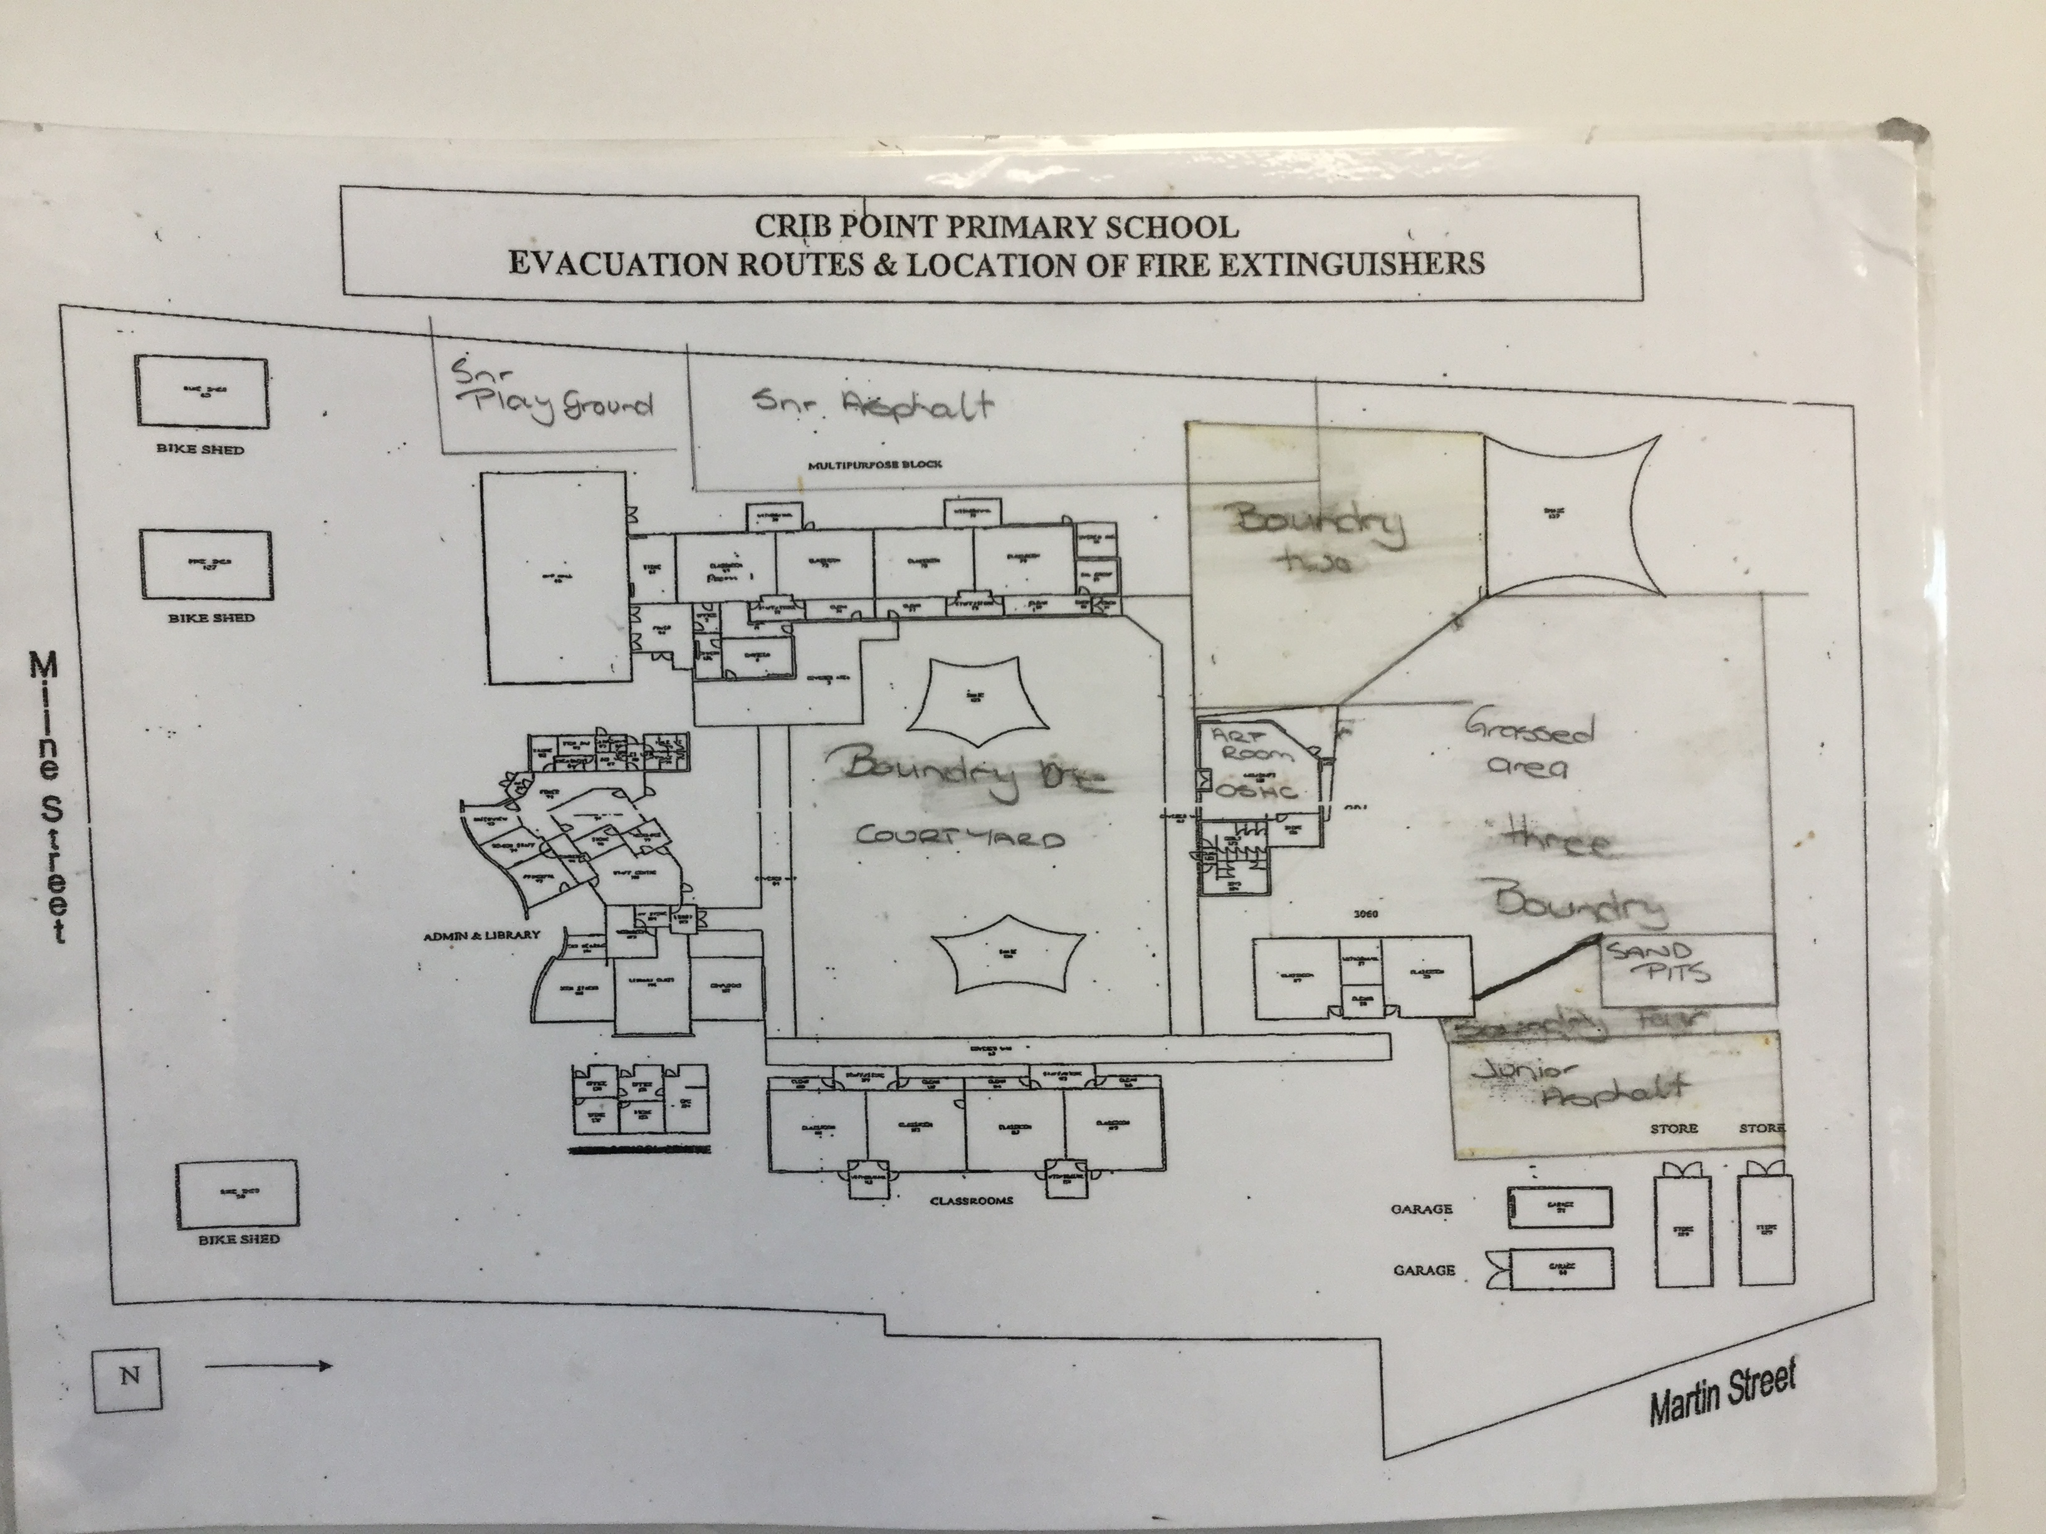
The designated yard duty areas for our school as at insert date eg Term 1, 2018 are junior and senior playground. If necessary due to behaviour, we will instigate a court yard duty roster as deemed necessary by the principal.

School staff must wear a provided safety/hi-vis vest whilst on yard duty. Safety/hi-vis vests will be stored just inside the staff room door on hooks.
Staff who are rostered for yard duty must remain in the designated area until they are replaced by a relieving teacher.
During yard duty, supervising staff must:
- methodically move around the designated zone and ensure that all areas are within line of sight to at least one yard duty teacher at a time.
- be alert and vigilant
- intervene immediately if potentially dangerous or inappropriate behaviour is observed in the yard
- enforce behavioural standards and implement appropriate consequences for breaches of safety rules, in accordance with any relevant disciplinary measures set out in our school’s Student Engagement and Wellbeing policy
- ensure that students who require first aid assistance receive it as soon as practicable
- log any incidents or near misses as appropriate on Compass
- if being relieved of their yard duty shift by another staff member (for example, where the shift is ‘split’ into 2 consecutive time periods), ensure that a brief but adequate verbal ‘handover’ is given to the next staff member in relation to any issues which may have arisen during the first shift.
If the supervising staff member is unable to conduct yard duty at the designated time, they should contact the Principal with as much notice as possible prior to the relevant yard duty shift to ensure that alternative arrangements are made.
If the supervising staff member needs to leave yard duty during the allocated time, they should contact the Principal but should not leave the designated area until the relieving staff member has arrived in the designated area.
If a relieving or next staff member does not arrive for yard duty, the staff member currently on duty should send a message to the office and not leave the designated area until a replacement staff member has arrived.
Should students require assistance during recess or lunchtime, they are encouraged to speak to the supervising yard duty staff member.

Classroom
The classroom teacher is responsible for the supervision of all students in their care during class.
If a teacher needs to leave the classroom unattended at any time during a lesson, they should first contact the front office for assistance. The teacher should then wait until another staff member has arrived at the classroom to supervise the class prior to leaving.

School activities, camps and excursions
The principal and leadership team are responsible for ensuring that students are appropriately supervised during all school activities, camps and excursions. Appropriate supervision will be planned for special school activities, camps and excursions on an individual basis, depending on the activities to be undertaken and the level of potential risk involved.

Further Information and Resources
- School Policy and Advisory Guide:
  - Supervision
  - Duty of Care
  - Child Safe Standards
  - Visitors in Schools

Review Cycle
This policy was last updated on July 2018 and is scheduled for review on July 2021. This policy will also be updated if significant changes are made to school grounds that require a revision of Crib Point Primary School Yard Duty and Supervision Policy.

